**AR TOOLS FOR ENERGY CONSUMPTION VISUALIZATION**

**HARINI K M** [**manimarndheebha@gmail.com**](mailto:manimarndheebha@gmail.com)

**DYUTHI R** dyuthi.r2005@gmail.com

**GOPIKA R** gopikark2005@gmail.com

**Panimalar Engineering college**

**ABSTRACT**

Energy Visualization Tools employing Augmented Reality (AR) technology could be a way for building facility managers to integrate energy use efficiency within their buildings. This way serves to overlay the live energy consumption data onto our physical environment and provides insights into hotspots where inefficiencies occur so proactive management can be implemented. For facility managers, this fresh workflow of visualization layers complex data with an intuitive touch that simplifies monitoring and enhances decision-making. For example, AR applications can flag energy inefficiencies that require targeted interventions and deliver prescriptive advice on resource allocation. Using AR technology affects the reduction of wasted energy, and since sustainability is crucial for some goals to be achieved with this in mind it simply makes building operations more competitive. Better still, AR can be integrated with a facility's building management systems (BMS) for seamless data-driven decision-making that helps organizations achieve significant energy conservation and carbon reduction. While these figures indicate a great larger opportunity, they realized the challenges of creating high barriers to integration costs and unified data standards as well as necessary stakeholder training. However, given the rapid development in technology and more organizations acknowledging that AR tools can help them improve their business offerings; we expect widespread adoption. In conclusion, the AR energy consumption visualization tool is a huge leap into the Energy Management industry landscape. By blending the insight to facility managers and helping promote an energy efficiency culture, these tools would largely help sustainable building operations achieve their environmental objectives by aligning them with economic incentives.

**I. INTRODUCTION**

Augmented reality (AR) has dramatically transformed energy management since it pushes the barriers of traditional facility manager solutions for superior efficiency. AR allows energy consumption data to be visualized in real-time on top of the physical environment and can provide immediate feedback for where there are inefficiencies, leading to better strategies for management actions. It enhances operational efficiency, supports sustainability objectives, and enables effective energy management which is becoming increasingly crucial to competitiveness. Augmented Reality is the technology that takes virtualization to the real world by introducing digital elements into a physical environment as it appear on your phone or tablet screen. Managed via an app, and available to end users through screens such as smartphones or tablets (and maybe eventually AR glasses), the tech offers a hands-on way of seeing data quickly in multiple dimensions. AR tools to drive facility managers --IFS Applications for Energy Management how teams might view their energy performance through the lens of their data-rich operational environments In today's integrated energy management, AR is essential to producing and displaying quickly consumed data. By combining AR with Building Management Systems (BMS), facility managers are immediately able to see operational metrics, and red flags of energy overuse, and intervene on time. Companies benefit from improved energy management, and reduced carbon footprints by having more accurate & faster decision-making as a result of this capability.

**II. VISUALIZATION OF ENERGY CONSUMPTION DATA**

Energy consumption data visualization real-time Augmented Reality (AR) techniques is a leading technology today. This includes the radical (an overlay of 3D models that show how much energy is used profile per building element and provides facility managers with a highly visual understanding of how their buildings perform their energy well). Interactive dashboards can also be integrated into AR apps so that users can interact with the real-time data and see different WHAT IF scenarios. Further, geolocation data could be used by AR for understanding energy consumption in the context of where one is located in a building to help improve an occupant's knowledge of how and why they use electricity. AR delivers an intuitive interactive experience, which is easier to grasp than numerical values that are often the basis for traditional energy data visualization tools. With traditional methods like standard dashboards or reports, it is common to represent data in a 2D format that might feel less interactive and dynamic. By contrast, AR tools may display dynamic visualizations as well and thus be tailored to specific energy inefficiencies while providing immediate context in the physical workspace. The immersive capability of the new platform allows facility managers to understand data relationships that can exceed thousands, hundreds, or millions — an incomprehensible task for most traditional tools. apps.

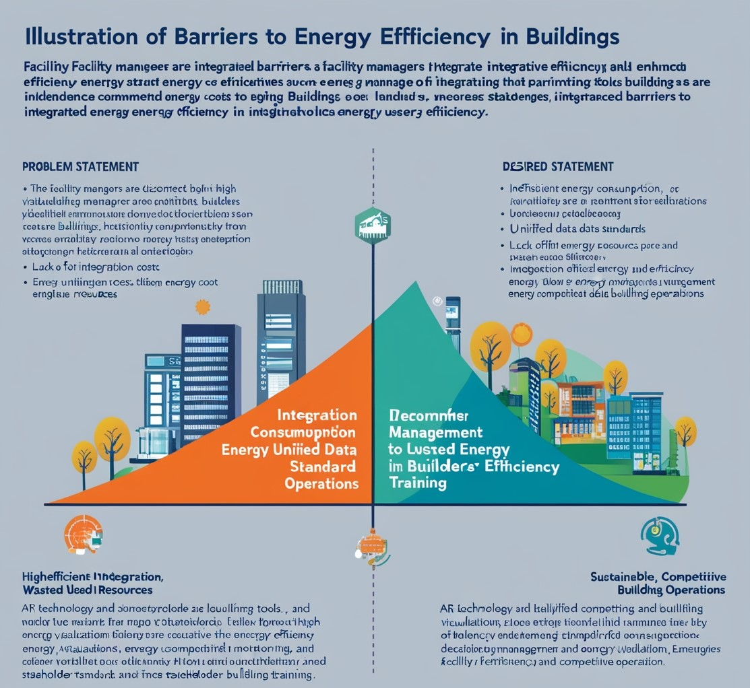

Fig. 1

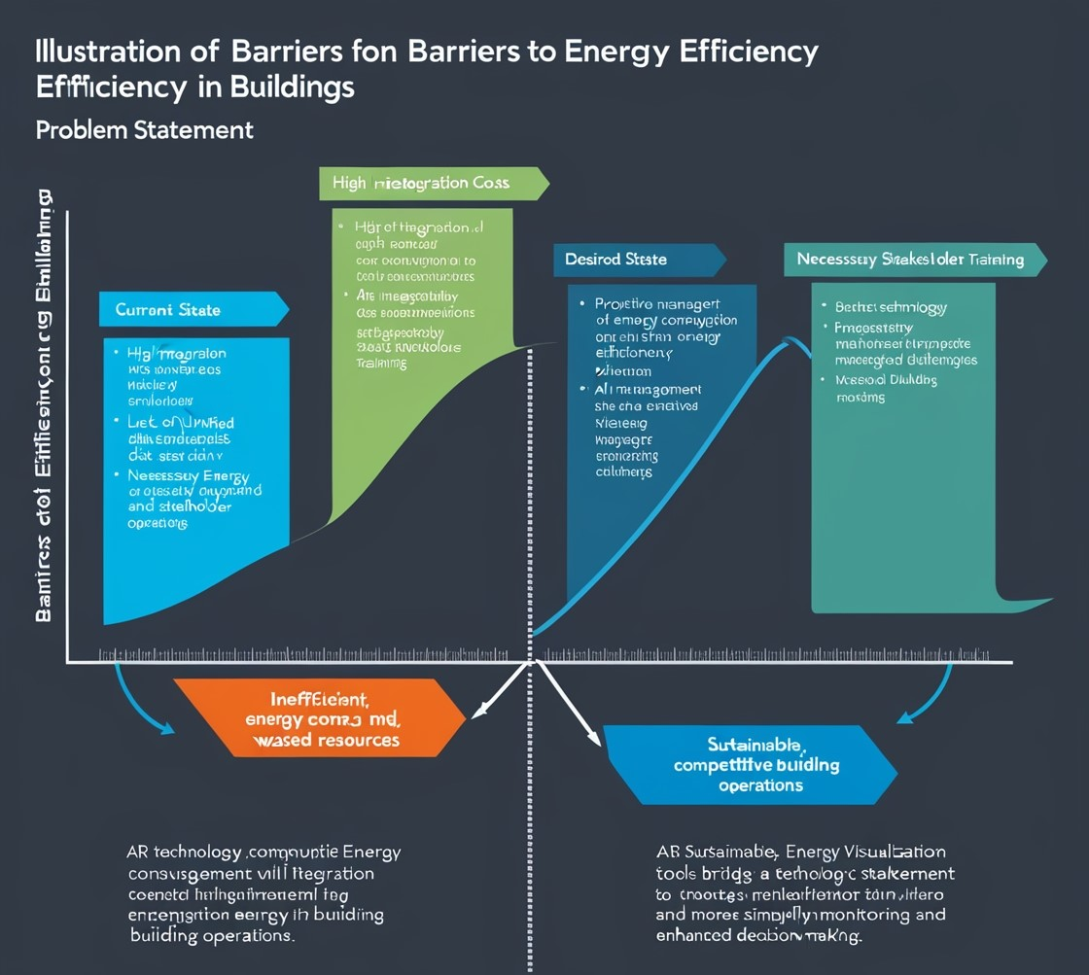

Fig. 2

**III. INTEGRATION WITH BUILDING MANAGEMENT SYSTEMS (BMS)**

By using the data analytics and visualization facilities of AR technologies, Augmented Reality (AR) can be integrated with Building Management Systems (BMS). Such integration enables the live 3D visualization of building systems and energy usage to be superimposed directly on top of the facility's real-world environment. Integrating AR applications with the BMS data streams allows facility managers to engage with operational metrics and energy statistics, delivering a significantly better understanding of their building operations. Combining AR with your BMS augments the bought of data available and in doing so, accelerates the ability for facility managers to make smart decisions. With seamless integration, you have what Davison notes as a 'continuous detect cycle' where hot spots can be popped into the data center analyst system milliseconds after they develop and long before it becomes visible in broader infrastructure management systems for example. All of these data streams can be cross-referenced with the physical space, enabling facility managers to see how energy is flowing throughout their facilities and allowing for faster decision-making based on solid performance metrics. This power of data ensures that not only organizations can act timely for the interventions, making them more energy-efficient and reducing their associated costs; but also infuses a culture of sustainability within an organization.

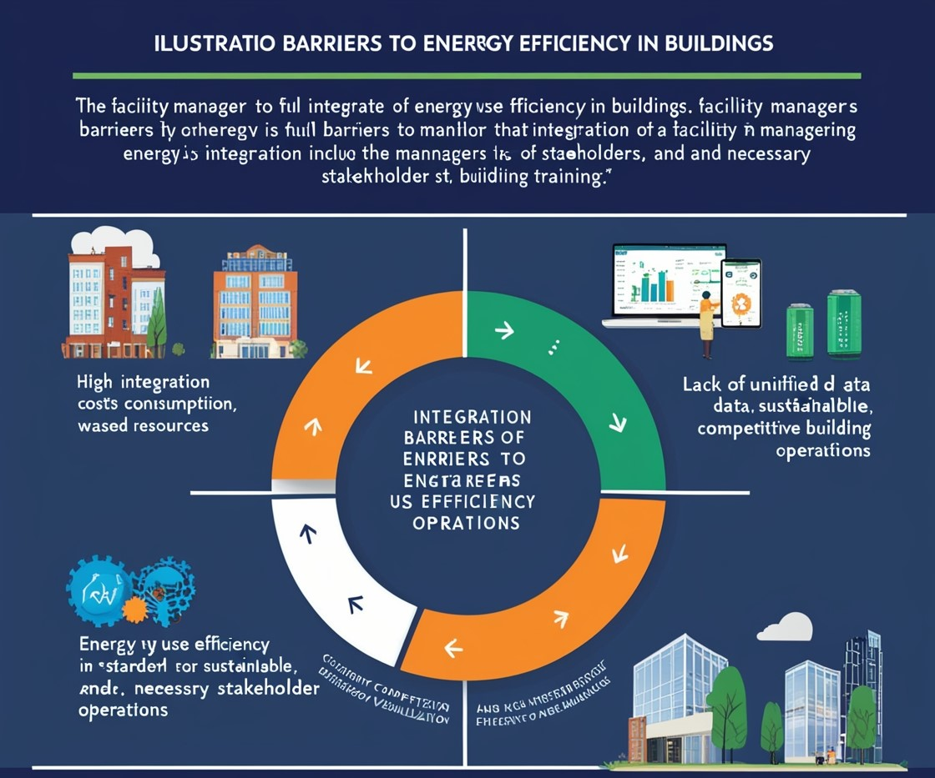

Fig. 3

**IV. FUTURE TRENDS AND DEVELOPMENTS IN AR FOR ENERGY MANAGEMENT**

Upcoming trends in Augmented Reality (AR) for energy management has mostly to do with enhanced data visualization and user interaction. The innovation also includes mobile AR applications, which provide facilities managers instantaneous energy data visualization as they walk around their buildings thus improving situational awareness. Also, AI and Machine Learning integrated with AR tools is anticipated to make predictive analytics a reality which will help managers predict possible inefficiencies on time along with proactive energy management. With growing sales of AR hardware, more and more businesses will be driven to embrace these technologies which in turn shall only give rise to innovation across a wide spectrum of energy management solutions. Augmented Reality (AR) is also slowly getting accepted and its benefits are being recognized, which in turn will help AR adoption across the energy management industry at large scale. With AR tools having such an intuitive interface, more organizations are searching for viable methods to eliminate energy costs and boost sustainable operations. In addition, the overall digital transformation across different sectors and the adoption of smart technologies like AR can be seamlessly combined with existing systems. Though there are still significant upfront costs and challenges such as data standards, the environmental benefit of sustainable building reductions in operational inefficiency has created a market base that welcomes AR adoption for energy management. Future predictions for AR-based systems reveal that operational effectiveness could be significantly advanced by implementing such technology in building operations & management and energy efficiency.

By 2030, we expect AR technologies to drive real-time monitoring and management of energy use with improved insights on the specifics around how power flows in buildings and systems are performing for facility managers. This ability would possibly cause lesser energy waste as it can stop the resource of extra strength and additionally permit one to make informed choices. In addition, as AR matures it will interface with Internet of Things (IoT) devices and building automation systems to better control energy fluctuations dynamically so that buildings not only operate cost-effectively but also adjust well to the changing conditions of an evolving low-carbon marketplace.

**V. CASE STUDIES AND REAL-WORLD APPLICATIONS**

Today, facility management is using a few Augmented Reality (AR) tools to improve operational efficiency and simplify workflow. BIM integrated with AR apps, for example, can help visualize facility layouts and maintenance requirements in real time so that managers are better equipped to handle the cognitive burden of complex information flows during maintenance (Jeffery et al. 2019). Similarly, tools that use a mobile application to superimpose maintenance data directly on physical assets work with facility managers but also anyone else trying to locate an issue fast or fix it. Some of the most inspirational use cases for AR in FM underscore impressive spikes as high as 5 to 7 times improvement per facility with maintenance efficiency and decision-making.

For instance, case studies within different industry contexts show that AR applications such as the ones described above allow a maintenance technician to see critical information (such as current operational conditions and spatial coordinates) reducing significantly on-site intervention time. These implementations offer lessons learned, like the need to engage stakeholders in AR integration and provide comprehensive training for staff to use the technology effectively. In energy management, AR has comparative studies that show the clear advantages it offers concerning traditional technologies. Conventional monitoring is historically based on static dashboards and reports that might be difficult for most non-experts to interpret; with AR, you will have the possibility of using visual 5D representations giving significant help in understanding how energy consumption varies over time (e.g., as a Daily Profile) and factors out inefficiencies at-the-moment of their occurence.

These studies indicate that not only are energy inefficiencies found more quickly and at a higher resolution with AR, but users engage in improved management of the information they find, which leads to overall superior sustainability outcomes than other techniques such as using data analysis tools alone.

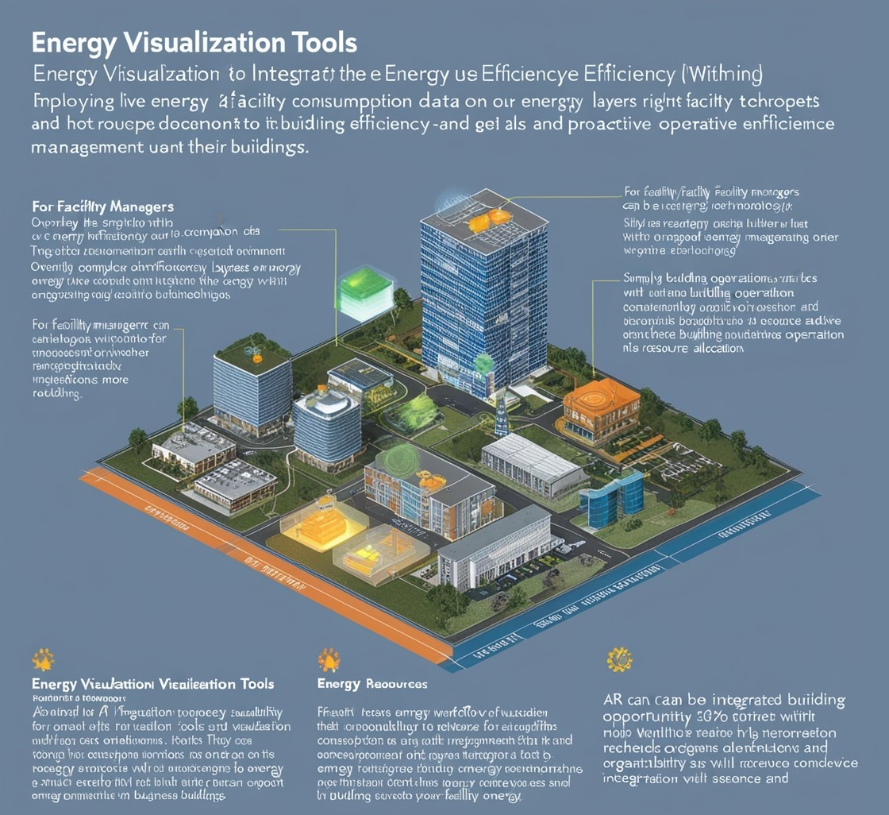

Fig.5

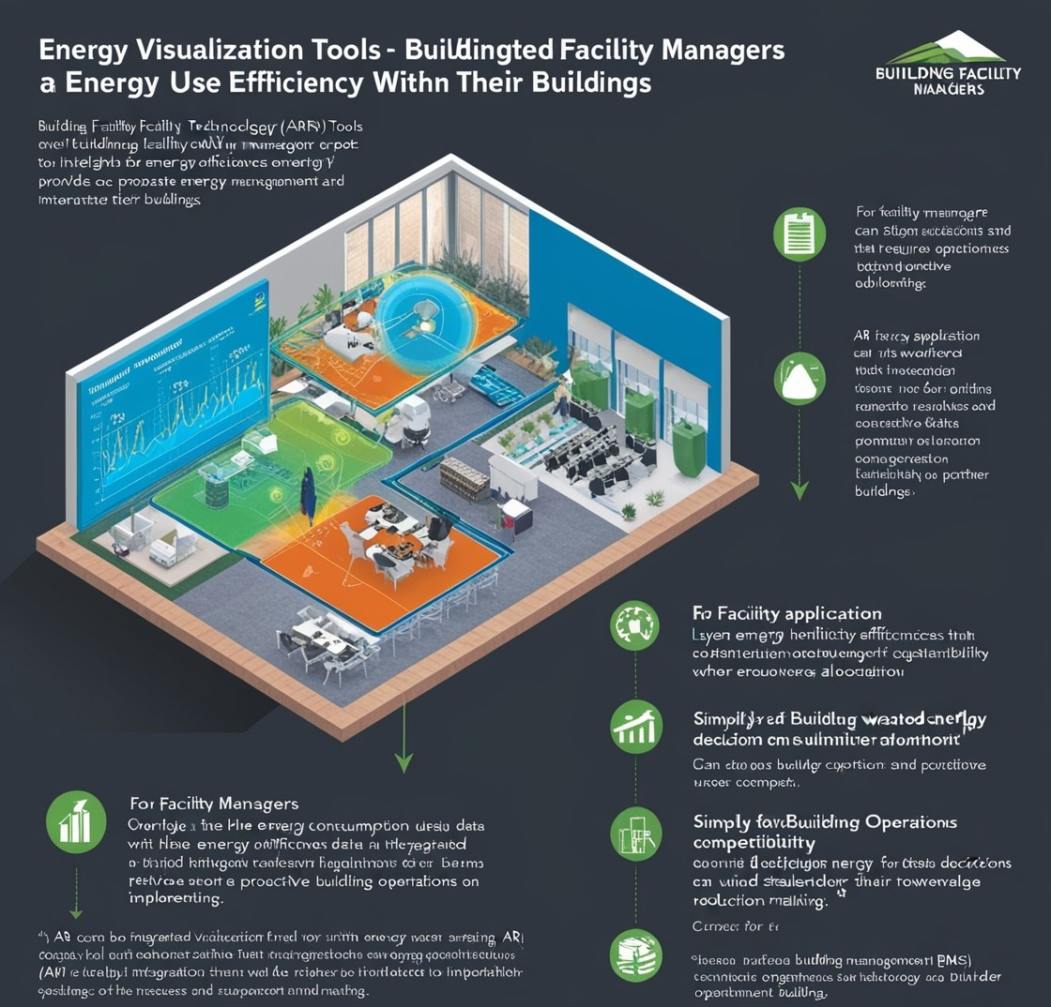

Fig. 6

**VI. ECONOMIC AND ENVIRONMENTAL IMPACTS**

A breakdown of costs and benefits of integrating Augmented Reality (AR) into energy management illustrates the promise of a tangible return on investment through enhanced operational efficiency, alongside a decrease in power consumption. Initial Costs to Implement augmented reality software and hardware facility manager training. These costs can be countered by savings that result from reduced energy use, more efficient maintenance, and the power of data visualization in real-time for management decision-making. A key distinction, contrasting the AR use case here and most other applications of AR up until now in driving efficiency is that these types are primarily intended to drive environmentally beneficial outcomes only secondarily benefiting economic incentive alignment at all. By allowing facility managers to see energy flows and defects in real time, AR also helps drive cost-saving measures that are both as environmentally friendly and sustainable. The ability of AR technologies to deliver synergy through these 3 pillars helps organizations achieve their sustainability objectives whilst still enhancing economic output. The heightened awareness and knowledge exist to leverage employee agency (both an input and an output of energy behaviour) in the promotion of PrCLC, and EQB&EZ practices, thereby promoting widespread organizational integration12. Furthermore, AR-enabled training programs can also help support this culture which gets only stronger by making people knowledgeable sound, and skillful to be energy-friendly.

**VII. ETHICAL AND SOCIAL CONSIDERATIONS**

However, the use of Augmented Reality (AR) in energy management presents several ethical implications that need to be carefully thought about. More importantly, concern has been raised that AR can be abused to capture ostensibly private/sensitive data of the employee (such as employees' movements and how much energy their departments use.) Failure to control this could potentially breach the privacy message so enterprises need to have a policy around them and employee consent. Further, it is important for AR technologies to not reinforce existing biases in energy management or make inequitable resource allocations thus threatening the ethical underpinnings of their implementation. Utilizing AR tools in the workspace may lead to profound social change, particularly when it comes to creating a more collaboration-friendly and engaging workplace. It provides a way to engage in immersive, interactive learning and operational environments, It can lead to an energy-wise labour force fully engaged in saving power. This heightened engagement may transform employee motivation for the workplace to be more sustainable, fostering a kind of collective responsibility at ground-level energy management practices. Then, there is always a risk of technological dependency where employees start to rely too much on AR tools because their regular problem-solving skills are getting rusted. They are of greatest importance as this would collect real-time data on energy consumption and user interactions, so it has to be ultra-secure concerning Privacy & Data Security. There are also data confidentiality tables that risk exposure from unauthorized access, and this can cause a substantial amount of harm to everybody in extremely large organizations. Offer security at top-notch for example, encryption, and safe data to store which needs protecting against threats. Organizations also need to be open about what data they gather and transparency on its purpose, this will help build trust with employees along with improved compliance when it comes to data protection. The concern with the advent of widespread AR deployment is that failing to account for this privacy repercussion could have a more general knock-on on effect employee morale and workplace relationships.

**VIII. CONCLUSION**

Including the use of Augmented Reality (AR) in energy management, thereby improving data visualization and operational efficiency. This data visualization capability helps you keep track of your energy consumption using real-time AR tools, enabling facility managers to make thoughtful and effective decisions. This study demonstrates that companywide AR use could result in significant energy savings and a generalized attitude toward efficiency, thereby reducing splits between economic gains at the cost of environmental objectives.

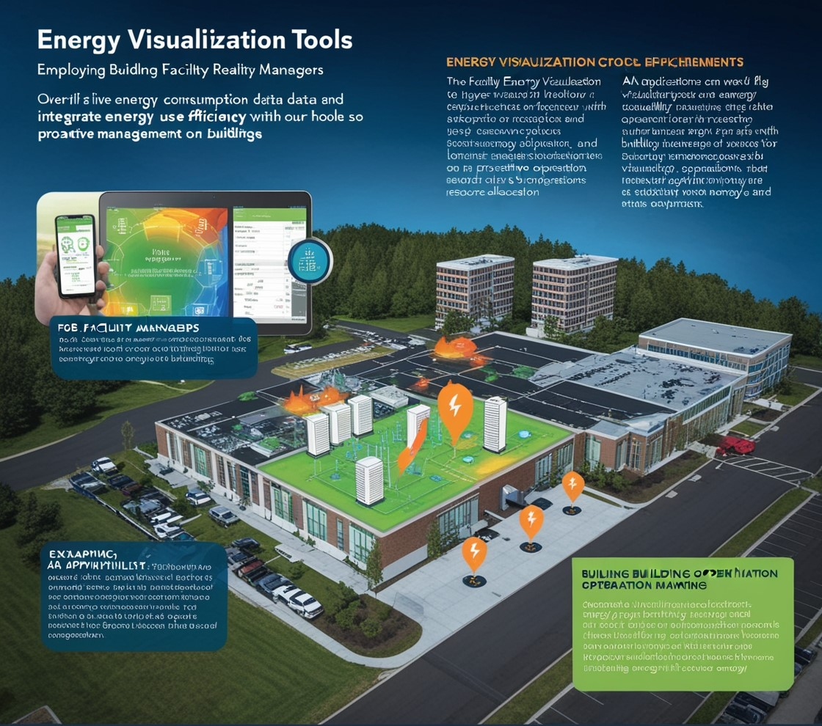

Fig. 7

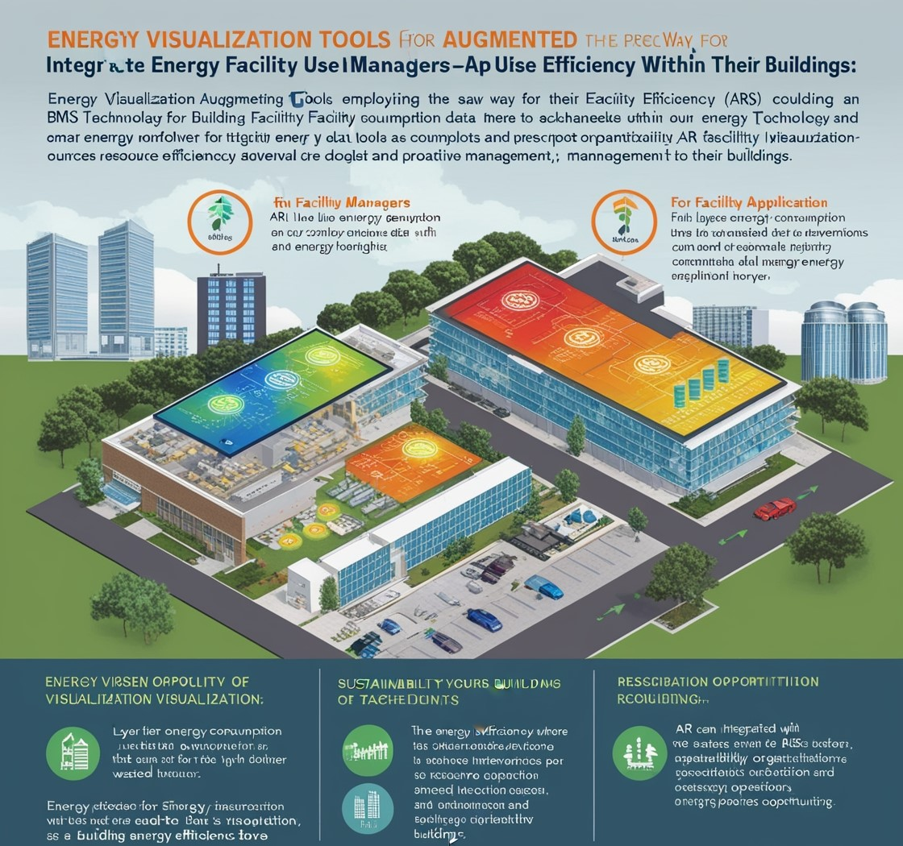

Fig. 8

**IX. REFERENCE**

1. Ong, S.K.; Nee, A.Y.C. Virtual and Augmented Reality Applications in Manufacturing; Springer Science & Business Media: Berlin/Heidelberg, Germany, 2013; ISBN 1447138732.
2. Ribeiro, T.R.; dos Reis, P.R.J.; Júnior, G.B.; de Paiva, A.C.; Silva, A.C.; Maia, I.M.O.; Araújo, A.S. Agito: Virtual reality environment for power systems substations operators training. In Proceedings of the International Conference on Augmented and Virtual Reality, Crete, Greece, 22–27 June 2014; Springer: Berlin/Heidelberg, Germany,2014; pp. 113–124.
3. dos Reis, P.R.J.; Junior, D.L.G.; de Araújo, A.S.; Junior, G.B.; Silva, A.C.; de Paiva, A.C. Visualization of power systems based on panoramic augmented environments. In Proceedings of the International Conference on Augmented and Virtual Reality, Crete, Greece, 22–27 June 2014; Springer: Berlin/Heidelberg, Germany, 2014; pp. 175–184.
4. Xue, H., Sharma, P.; Wild, F. User Satisfaction in Augmented Reality-Based Training Using Microsoft HoloLens. Computers 2019, 8, 9.
5. Horejší P and Novikov K and Šimon M 2020 “A Smart Factory in a Smart City: Virtual and Augmented Reality in a Smart Assembly Line” J. IEEE Access 8 (IEEE) pp 94330-94340.
6. Alonso-Rosa M, Gil-de-Castro A, Moreno-Munoz A, Garrido-Zafra J, Gutierrez-Ballesteros E and Cañete-Carmona E 2020 “An IoT Based Mobile Augmented Reality Application for Energy Visualization in Buildings Environments” J. Applied Sciences 10 (MDPI) pp 1-15.
7. João D Vinícius, Lodetti P Zenni, Martins M A Izumida and Almeida J F B 2020 “Virtual and Augmented Reality Applied in Power Electric Utilities for Human Interface Improvement - A Study Case for Best Practices” Proc. Int. Conf. on Technology & Engineering Management TEMSCON (June 3-6, 2020, MI USA) (IEEE) pp 1-4.